**BDW Assignment 4**

* **Tableau**
  + Daily Rate for cars

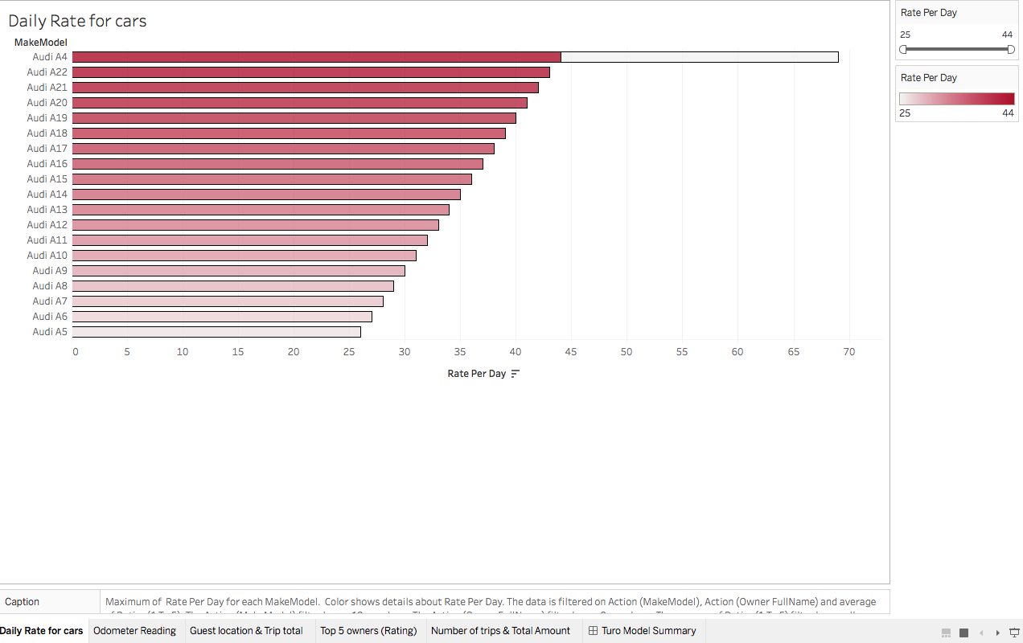

* + Odometer Reading

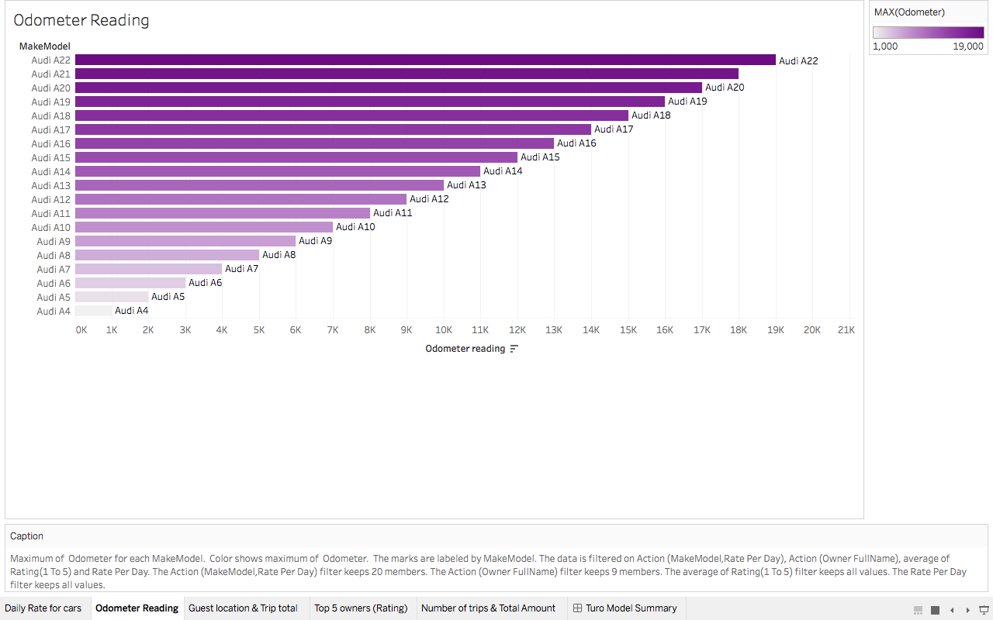

* + Guest Location and trip total

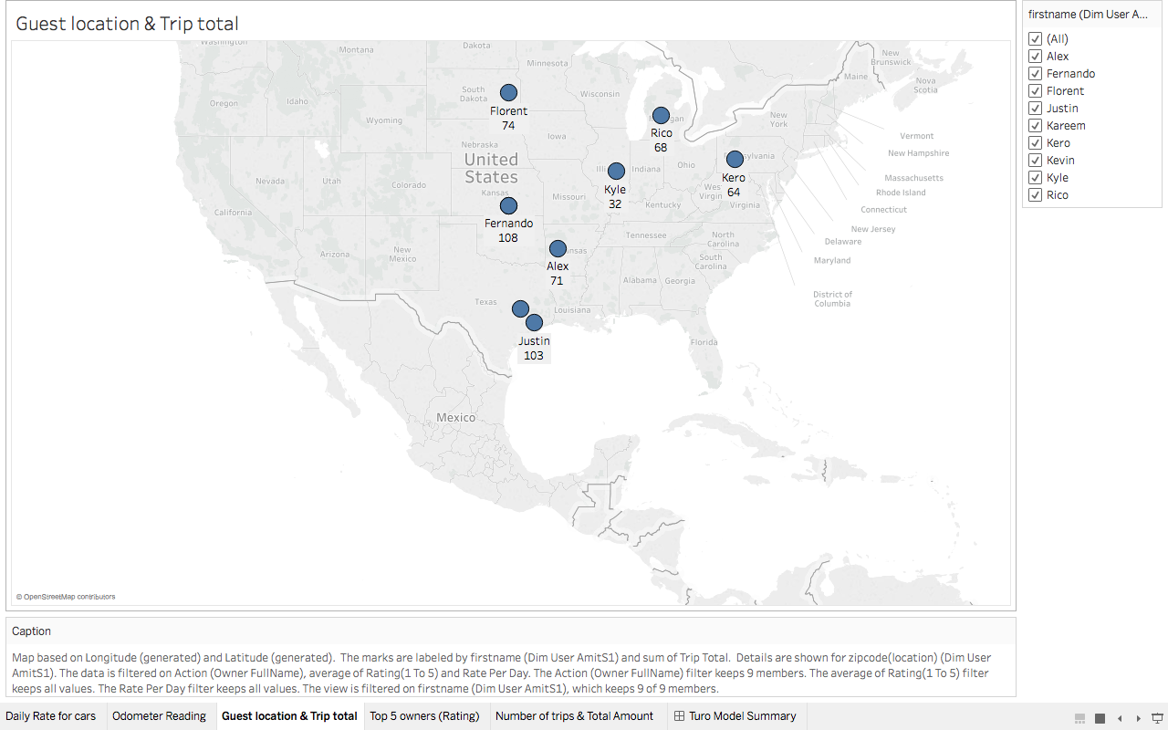

* + Top 5 owners (Rating)

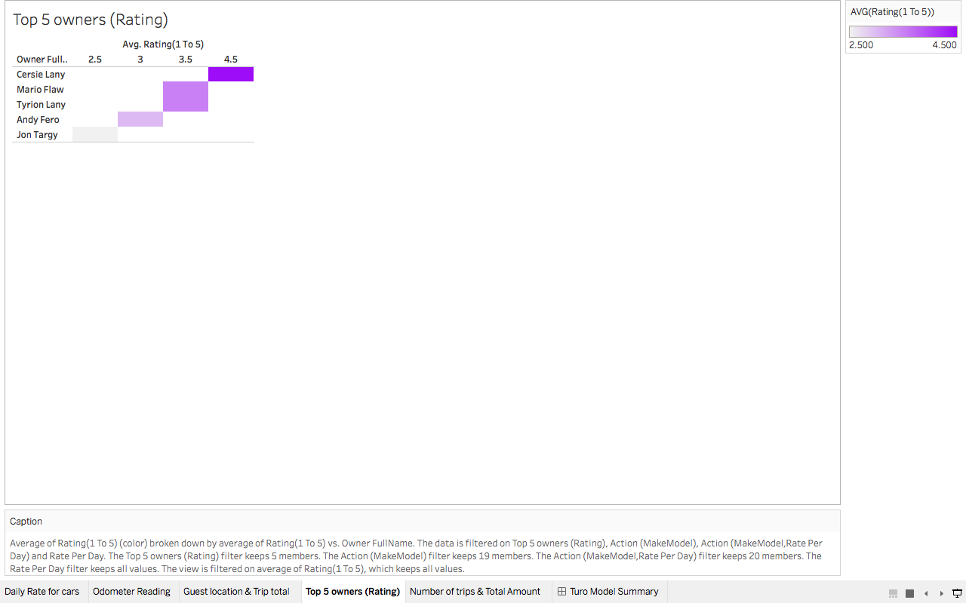

* + Number of trips & total Amount

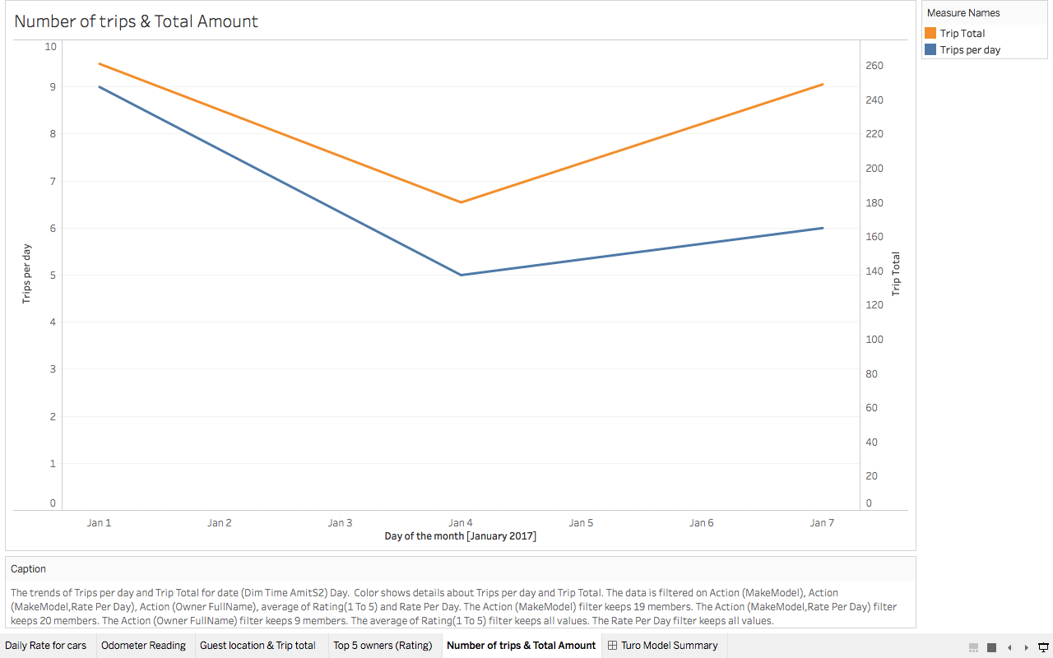

* + Dashboard

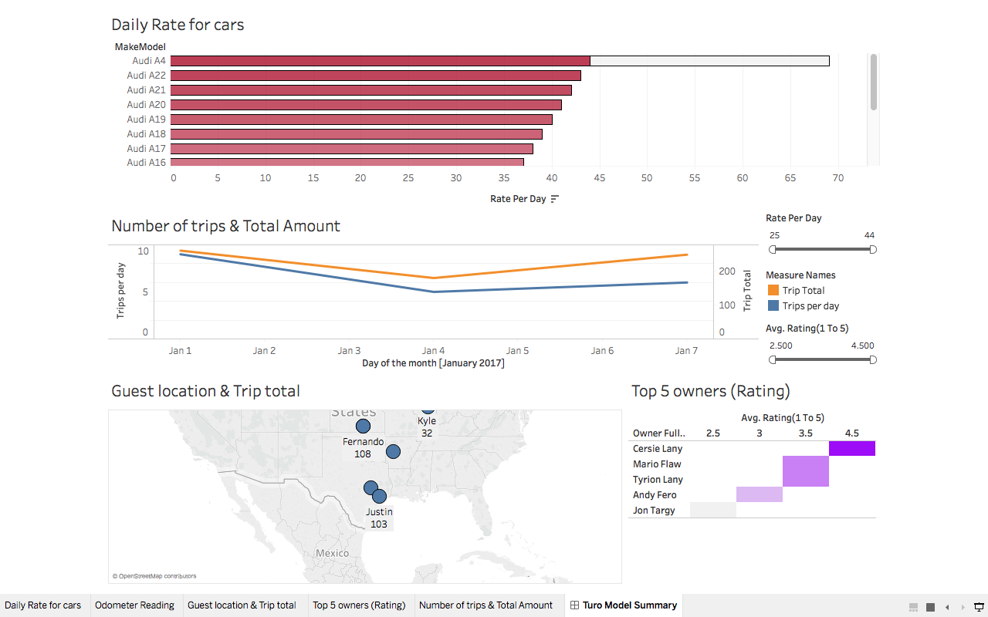

* **Web Intelligence**

**Dashboard**

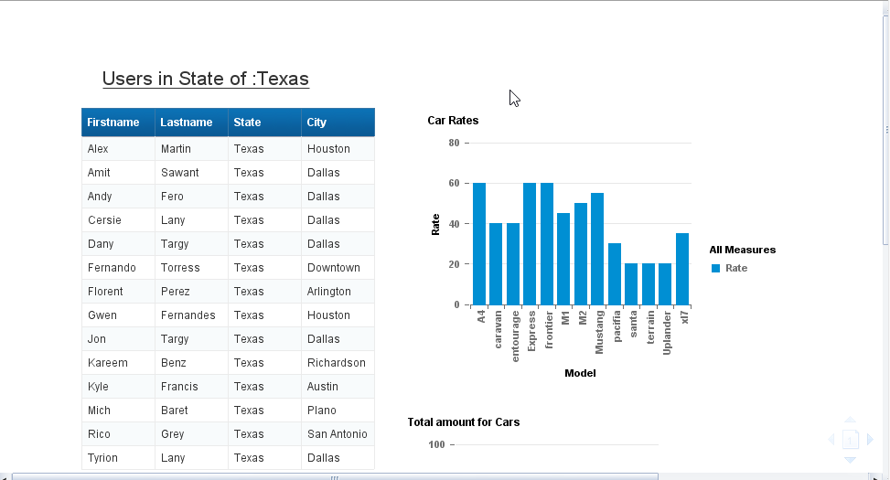

**Dashboard**

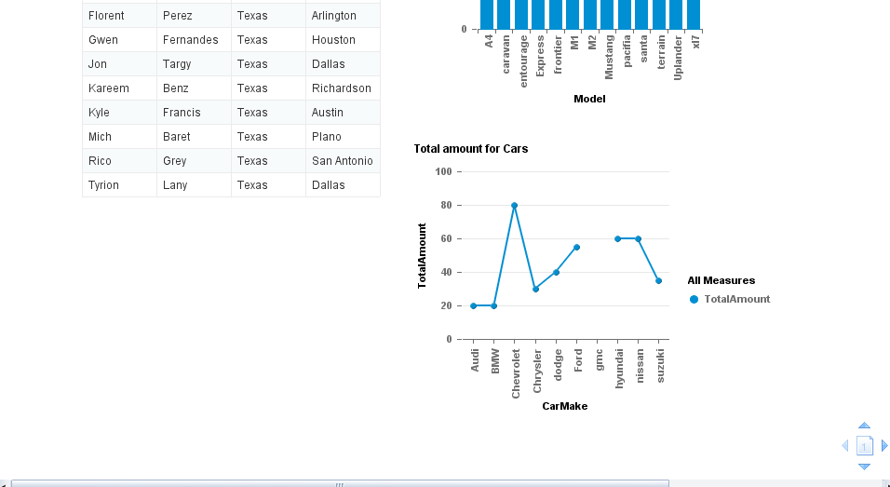

**Input Controls**

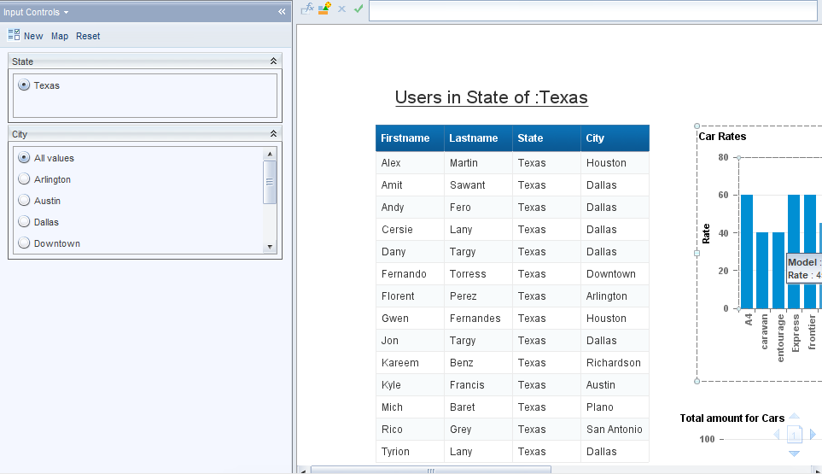

(Group feature for input control not available in Web Intelligence)

**Report Level Filter**

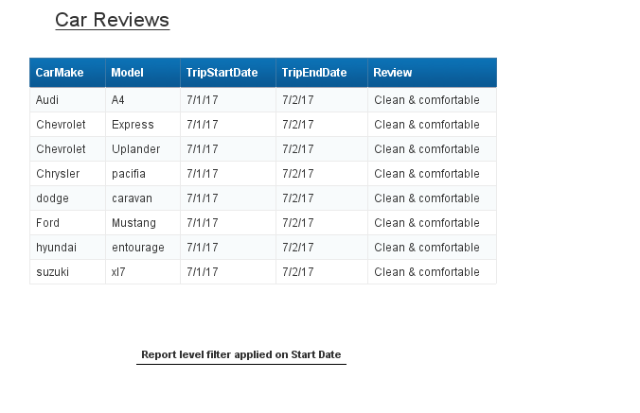

**Report Level Filter**

